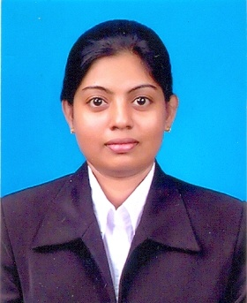

**CURRICULUM VITAE**

**SANDEEPANI GOPIKA DIAS**

**No: R ¼, Soysa Flats, Moratuwa.**

**Tel: 011 - 2625950 / 0766-463571 / 0766-102093 | Email: sandeepani.dias@yahoo.com**

**PERSONAL INFORMATION**

Name in Full : Sandeepani Gopika Dias

Date of Birth : 30st July 1980

Age : 34 Years

Nationality : Sri Lankan

School Attended : Girls’ High School, Mt- Lavinia

**EDUCATIONAL QUALIFICATIONS**

* ***G.C.E (O/L) Examination in 1997***

Subject Grade

Sinhala C

Home Science C

Social Studies C

Dancing C

Mathematics S

English Language S

Science S

Buddhism S

* ***G.C.E (A/L) Examination in 2001***

Subject Grade

Sinhala Language C

Logic C

Economics S

**OTHER QUALIFICATIONS**

* Have followed one year English & Computer Course in British Council.
* Have followed three months Airline Ticketing Course in Polytechnic Limited.
* Have followed Background to the Low studies in CFPS
* Have followed Computer Course in Laneway institute – MS Word / Excel, Power point, MS Access, Internet & E mail.
* At present following AAT and Auto Cad course in E- Soft computer Studies (Pvt) Ltd.
* At present following Japanese Language course in Sasakawa Hall.

**EXTRA CURRICULAR ACTIVITIES**

* Participated in Athletic, Performed as Class perfect for two years.
* Participated in the Arts Day Celebration at School.
* Participated in “Muthuhara” the TV Programme.
* Member of British Council Student’s Association and worked as a Leader in 1998.
* Head perfect of Sunday school at Soysapura.

**WORK EXPERIENCE**

* Employed in Export Documentation work at AB Mauri Lanka (Pvt) Ltd.
* Five years experience in Maliban Biscuit Manufactories Ltd as a Administration work.
* Five years experience in Barbren Engineering Constructions (Pvt) Ltd as a Purchasing Executive and also worked as a all round valuable asset to this Organization.
* Currently Working as a Purchasing Executive at Lanka Hotels & Travels (Pvt) LTD. Wattala ( Elephant Reach – Yala )

**NON RELATED REFEREES**

Mr. Buddika, ,

Personnel Executive

Elephant Reach –Yala

Corporate Office –

Lanka Hotels & Travels Pvt Ltd,

No: 38, Station Road,

Wattala,

Contact No: . 077-1978032

Mr. Bindu Dias

Maintenance Engineer

Hikkaduwa Beach Hotel (Pvt)Ltd.

No.298,Galle Road,

Hikkaduwa,

Contact No: 077 - 0136480

In the event of my being selected for this post, I assure you sir that I will carry out the duties assigned to me your entire satisfaction.

05.07.2015 Sandeepani

………………………. …………………………….

Date Signature